* Sensors Research
  + Sensors for security
    - What type of sensors will be suitable and be able to work on a moving platform?
      * Passive IR?
        + What is their range?
        + Do they need to be somewhat high above the ground to effectively see the IR signature of a person? (feet and legs might not be that warm)
      * Sound?
        + Need to decide what sound volume or frequency we will be listening for

Right now we are aiming for broken glass sounds but are there other frequencies/sound volumes that would work too?

* + - * + Need to not mistake other sounds as threats

Normal nighttime sounds (broad)

Robot’s own movement (talk with Drive Base)

* + sensors for navigation
    - Most likely a few ultrasonic sensors
      * Need ones at different heights
  + All sensors must be compatible with the core electronics (you know who to talk to)

Navigation Sensors

Ultrasonic sensors

HC-SR04

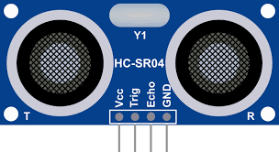

[Datasheet](https://cdn.sparkfun.com/datasheets/Sensors/Proximity/HCSR04.pdf) Elec Freaks

* DC 5V supply
* Trig
* Echo
* Ground
* Working current 15mA
* Working frequency 40Hz
* Range: 4m-2cm
* FOV: 15°

Warnings:

It is not suggested that the module be connected directly to electricity. If it is connected to electricity, the GND terminal should be connected to the module first; otherwise, it will affect the module's normal work.

When tested objects, the range of area is not less than 0.5 square meters and the plane requests as smoothly as possible, otherwise, it will affect the results of measuring.

The sensors will interfere with one another. It is suggested that we stagger the measurement of each sensor. Probably a couple of milliseconds difference.

* Very cheap
  + $2 - $7 per single
  + [13$ for 10](https://www.amazon.com/ACEIRMC-HC-SR04-Ultrasonic-Distance-ElecRight/dp/B09J4BN46F?source=ps-sl-shoppingads-lpcontext&ref_=fplfs&smid=A3S807LE0L63AP&th=1) Amazon

Detection Sensors

What is a PIR (Passive Infrared) sensor?

[Source](https://www.aaisecurity.co.uk/news/pir-sensor/#:~:text=PIR%20(passive%20infrared)%20sensors%20utilise,wavelengths%20can%20detect%20such%20activity.): AAI Security Systems

“PIR (passive infrared) sensors utilize the detection of infrared that is radiated from all objects that emit heat. This type of emission is not visible to the human eye, but sensors that operate using infrared wavelengths can detect such activity. They are sometimes referred to as ‘motion-based detectors’, as they sense the presence of people, animals, and objects through the movement of their infrared wavelengths.”

* Detects movement of a person or animal’s IR wavelengths
  + Does not detect heat
* Emits not energy, hence passive

“At a basic level, PIR sensors operate using positive differential change. Two IR-sensitive slots sit in front of the lens, with their field of “vision” determining the range of detection. While ‘idle’, the ambient level of infrared detected in the room (naturally emitted by all objects) is the same on both slots. The minute an object, person or animal moves through the detecting area, it is sensed by one of the slots before the other, causing a positive differential as it passes by, and a negative differential change as it leaves the area.”

* Rather large
* Can be expensive
  + [Found one cheap for $13](https://www.amazon.com/Dual-Passive-Infrared-Motion-Detector/dp/B07RQCLB2Z/ref=asc_df_B07RQCLB2Z/?tag=hyprod-20&linkCode=df0&hvadid=693308325595&hvpos=&hvnetw=g&hvrand=10087680360542337169&hvpone=&hvptwo=&hvqmt=&hvdev=c&hvdvcmdl=&hvlocint=&hvlocphy=9031618&hvtargid=pla-943553799999&psc=1&mcid=8ea2ffb29c6534d584a38f60e3099e17) Amazon

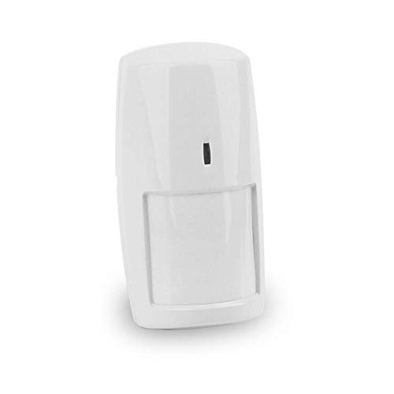

Specs of [this PIR](https://www.amazon.com/Dual-Passive-Infrared-Motion-Detector/dp/B07RQCLB2Z/ref=asc_df_B07RQCLB2Z/?tag=hyprod-20&linkCode=df0&hvadid=693308325595&hvpos=&hvnetw=g&hvrand=10087680360542337169&hvpone=&hvptwo=&hvqmt=&hvdev=c&hvdvcmdl=&hvlocint=&hvlocphy=9031618&hvtargid=pla-943553799999&psc=1&mcid=8ea2ffb29c6534d584a38f60e3099e17):

* Range: 10m
* Working Voltage: DC9-16V
* Current Consumption: ≤25mA(DC 12V/hour)
* Working Temperature: -10°C/+50°C（14°F/122°F）
* Sensor Type: Dual pyroelectric infrared sensor
* Mount Method: wall mounted
* Installation Height: about 2.2m
* Detection Distance/Anti-pet Level: 10m/25kg
* Detection Angle: 110°

Further research:

[Wikipedia](https://en.wikipedia.org/wiki/Passive_infrared_sensor#Practical_Implementation)

PIR sensors are designed to detect changes in infrared radiation caused by the movement of objects. On a mobile platform, especially one that moves frequently or at varying speeds, the sensor might have difficulty distinguishing between the platform's own motion and that of external objects (e.g., humans or animals).

Conclusion:

Regardless of what PIR sensor we use, activating it while in motion is not an option. If we do want to use this sensor we will have to stop the robot, turn on the PIR, wait for some time to see motion, then turn it off and move again.

Sound Sensor

FC-04

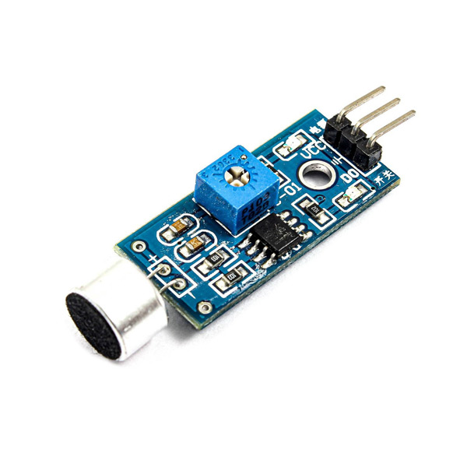

Can't find an exact datasheet so far

[Source](https://electropeak.com/learn/interfacing-fc-04-microphone-sound-sensor-module-with-arduino/): Electro Peak and [ROBU. IN](https://robu.in/sound-sensor-basics-pin-configuration-working-applications-and-interfacing/#:~:text=Working%20Principle%20of%20Sound%20Sensor,the%20help%20of%20a%20microphone.)

* DC 3.3V to 5V supply
* Ground
* Analog Output
* Sensitivity can be adjusted with the potentiometer (Not exact)
  + Will hear all sounds above this set volume.

Time of flight sensor

[video](https://www.google.com/search?sca_esv=e2d0a23f1e404477&rlz=1C1VDKB_enUS968US969&sxsrf=ADLYWILgOhr6M3wUVXHOowI0BEyGY5aiaQ:1729050644823&q=time+of+flight+sensor&tbm=vid&source=lnms&fbs=AEQNm0A2upiO_GHeTz6R89sNEjTHXSUfB8x3gweQ77S5CBNH1r1tfg6CCs305vguWnvfb1aZG3zHrqVnnqUwNe3YK0gUp-BKUi5pzFiD0K2vlLumTJ9G4vOFxQJCl365W4CKdBeEkZRQ5F84sQy2quIiBjXzzbjRupT7bzeyAEZH64yhIaoSj_gbRPBv4MJaaxCOv7Zb4yRFtY__1de_RGOlex78w9M-yQ&sa=X&ved=2ahUKEwik2-7L_5GJAxUdI0QIHfQpKmYQ0pQJegQIERAB&biw=1536&bih=776&dpr=1.25#fpstate=ive&vld=cid:9c929a79,vid:mxMhFZYyAjQ,st:0)

Generally, at 1m to the target, a [TeraRanger](https://www.terabee.com/time-of-flight-principle/#:~:text=Time%2Dof%2DFlight%20(ToF)%20sensors%20are%20used%20for,the%20distance%20between%20the%20points.) One sensor is measuring an area approximately 4cm by 4cm.

Could replace the passive IR sensors: [link](https://www.terabee.com/shop/people-counting/terabee-people-counting-l/)